**Proper Time Booking**

Time should reflect accurately the amount of time it took to perform the work and then as well to perform the PTP/JSA.

PTP is required for every single work order, JSA are only required when the work is not a daily, repetitive work, or visual check. 13 weeks, follow ups, projects, 26 weeks, weeklies all require JSA’s.

If a PM calls for an estimated time and the amount of time you spent performing the work and completing the PTP/JSA is within 15 minutes of the estimated time for the PM, only a comment of what was found and when it was completed needs to be placed in the comments. If the time it took to perform the work is outside the 15 minutes window of what is estimated for the PM, then comments need to be added as to why the work was outside the 15 minute range that is estimated in the PM.

For instance if a PM calls for .5 and the time it to you to perform the work was .25-.75, then only a comment of what was found and when it was completed needs to be placed in the comments.

If the PM calls for 1 hr, and the time it takes you to complete the PM is less than .75 or greater than 1.25, then comments need to be added as to why the work was outside the 15 minute range that is specified in the PM (1hr).

**Comments**

Comments should be to the point and informative. When placing comments please make sure we are being as detailed as possible without including information that is unneeded.

For example, if you cannot complete the PM, please add a comment explaining why they work could not be completed and when the work is planning on being completed. Also if you are passing the PM along to another tech please place that in the comments of who, only do so after talking to that person.

**Examples-** For comments inside the 15 minute window. Follow up WO’s created for work during DTW or later in shift, the WO number should be put in the original WO comments.

* PM successfully completed 7.27.2020 no issues found. – Good
* PM successfully completed 7.27.2020, head roller making a grinding noise. Will inspect during DTW 7.28.2020 follow up #xxxxxxxxxx created. – Good
* PM not completed due to SEV situation on SLAM 2, PM passed on and reassigned to the FHD tech @mccleanm for completion.- Good
* Done- wrong
* PM complete- wrong
* Initials- wrong
* PM passed to FHD- wrong.

**Equipment Assigning**

Equipment should be narrowed down to the lowest asset possible. If you are doing checks on equipment as follow up, then each piece of equipment needs to have its own follow up created for tracking purposes.

For example if you check the first and second merge belt, you need to create 2 follow up WO’s one for each piece of equipment.

* WO 1- Inspecting 601000 during operational runtime. Equipment assigned to 601000
* WO 2- Inspecting 601010 during operational runtime. Equipment assigned to 601010.

Comments then should be placed on the equipment for all work was performed on the equipment i.e. IR/Strobe/Ultrasound. Also all the comments stated above if time does not reflect what you suggested for the follow up.

There will be fewer follow ups assigned to general categories. For example if you walk the mezz looking at equipment pick out a few pieces and go over them in detail, then the next night or day follow up where you left off with the same detail. Do not try to walk everything and book 2 hours to sorter.recirc.induct.general.

Also if you are taking pack lane calls for ranpaks, spoo machines, wat tapers, ect. Assign them to PCK.LN not the Dematic equipment number in EAM.

For instance below you see PCK.LN.01, this is the equipment you should use for pack lane calls that do not pertain to the Dematic equipment on that line. PCK.LN.01-03 and PCK.LN.01.201000RA are both wrong for those types of calls. If you are taking these calls please compile them into 1 ticket with comments for all the calls on that line that were taken.

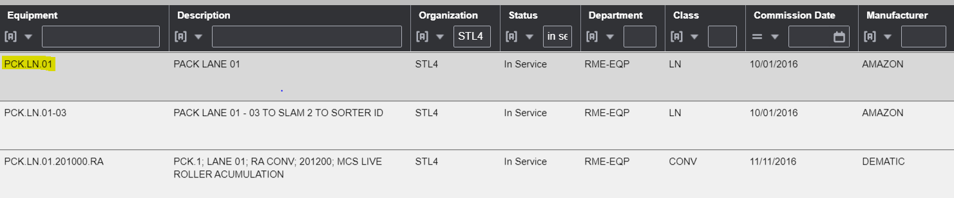

**Examples of Comments**

3-4 sp00 machine cord missing/replaced, 3-6 WAT taper keypad issues replace WAT taper, 3-1 table adjusted for AA.-Good

2-5 Andon light not working, replaced power cord. 2-4 Pedal for Ranpak not working, replaced foot petal. - Good

Line 3 issues- Wrong

Line 5 wat taper issues- Wrong

Line 5 and 6 calls- Wrong

For pick carts do not worry about assigning it to that specific cart because they are incorrect in EAM, with that being said if we come across more equipment that we cannot specify in EAM let us know.

**PIT Red Tag**

PIT red tag is for nights and for 1 person only, you should be booking the time that it takes you to walk the PIT corrals and enter the red tags into iWarehouse. Each night should be different because the amount of red tags varies.

* PIT red tag walks should be assigned to learning for the equipment since they are the ones tracking it. We will still enter and do the work but the equipment will be assigned to learning in EAM.
* All other PIT calls should be tagged to the equipment below, with comments on what happened, how it was repaired, or if it was passed on or parked, red tagged ect.
  + Always include the PIT equipment numbers and what the issues were.



**DTW Time Fluff**

This goes for all time but we are seeing an abundance of time being fluffed during the DTW. The DTW is the best time we get to do the most work we can on equipment without interruption or shutting down operations, with that being said we should be utilizing every minute of that time to ensure we are repairing and completing work that needs to be done. We also have an abundance of work that we could be doing during that DTW and should be completing that work if we do not have more pressing issues.

Example- we have numerous techs that claim to be able to change a takeaway v-belt in 35-45 minutes but for some reason people are booking 2 hours to a vbelt change during the DTW? If we are able to change this equipment in 35-45 minutes, then the time booked should reflect what it takes to make the repair.

**Projects**

Projects are a more difficult subject when it comes to ensuring we are booking the time to the correct equipment. We understand with guard rail there is no equipment in EAM to track those issues, with that being said please assign it to the according area where the repair or change was needed or to the department requesting the change. (i.e. general outbound, inbound, HR, Learning). If you have questions please reach out to management.

Another example is racking there is no equipment, so we should be charging that to Safety since they are the ones auditing that equipment.

**SLAMs**

Time booking for SLAMs has become a very generic topic with just SLAMs or SLAM1/2 as equipment. All the equipment that pertains to different beds on each SLAM, those specific pieces of equipment are in EAM see examples below.

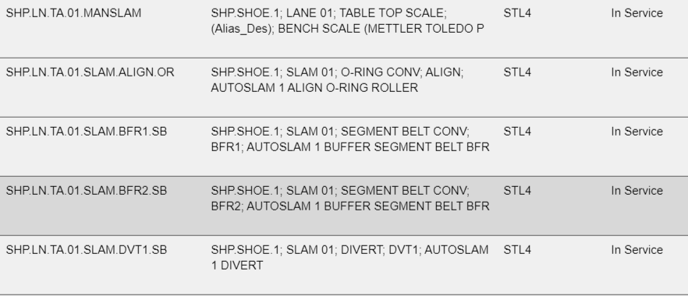

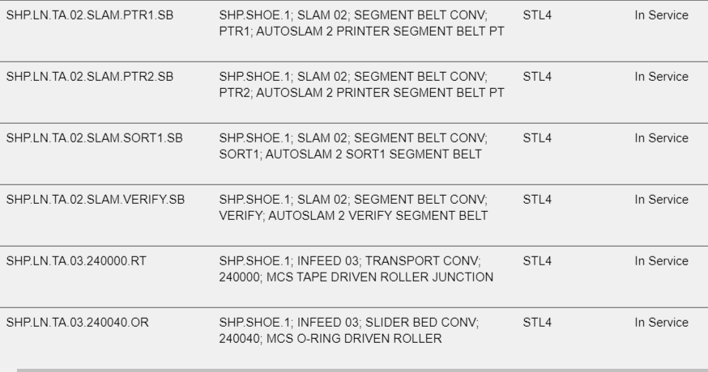

As you can see all the equipment for both SLAMs have been entered in EAM and need to be utilized for tracking. If you are adjusting anything on these sections of SLAM, then the equipment in EAM needs to reflect that as well as the comments entered.

**Chutes/PowerTrax/FlexConveyors**

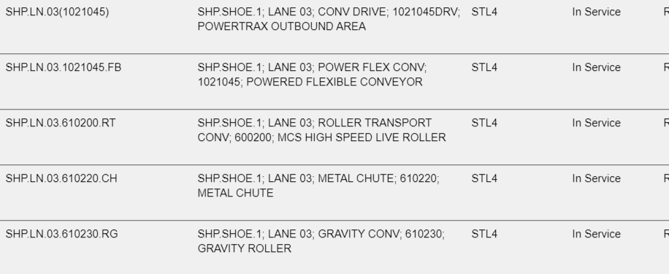

Above you can see above all equipment for each chute/flex conveyor/powertrax/ and gravity roller have been placed in EAM. With this equipment being in EAM there will be no more general dock calls with time booked to them for changing bands ect.

* Instead since this equipment is in EAM we will be booking the parts and time to the equipment for each one of these calls.

**Examples**

* If you are called for OB dock for bands on lane 4 and 5 each one needs their own WO created to track which piece of equipment the work was performed on.
* If you get called for lane 4, and while there are told the powertrax is not operating correctly, then you need 2 WO’s. 1 assigned to the powertrax for work completed, and a second for the time spent replacing bands on just the flex conveyor.
  + Comments should reflect the work done in detail for each WO and piece of equipment.
    - A simple replaced X bands on flex conveyor lane 4 will suffice.
    - If it is a more serious issue like an accumulation board, we need to comments in detail on the issues found and how we came to repair the conveyor.

**Parts**

If you are using parts for a repair you must take a laptop to the parts cage and take the part out in real time. Before you leave the cage with the part, it should reflect on the parts form what was taken, in the EAM WO what is being used, and on the sign in sheet for the cage.

**Tools and Computers**

This one has been reiterated repeatedly in the past, for any job you must take a laptop and ALL tools with you. It does not matter if you believe you will only need a screwdriver and pliers for the job, ALL tools must be taken incase another call comes up or if other issues arise, then we will be prepared. The same goes for projects or jobs in the racks, whatever the case tools and laptops must be taken with you.

Examples

If you are in the cage working on a project, you must take your laptop and tools with you.

If you are using a lift to clear jams or repair VNA netting issues, ect you still need a laptop and tools for the job. ALL your tools should still be close by and easily accessible incase issues were to arise.

If you are called up front to work on a project or do a TT, laptop and all tools must be taken.

**Follow Ups**

Follow ups should be created before the work is done, to ensure the PTP and JSA are done in accordance to Amazon standards. With that being said use your best educated guess as the time it will take to complete, if you know you average .25-.5 calls on a single pack lane a night then reflect that in the follow up. Using the same guidance as stated above for comments on PMs for follow ups and projects.

**Piggy Backing Time**

If we are answering small calls only 1 person should be handling the call, if issues arise and help is needed then that needs to be reflected in the comments as well. You should not be booking time to someone else’s WO because you do not have anything to book your time to. There is plenty of work to do and plenty of checks we could be doing each night that would get everyone involved in looking at equipment more in detail and save us from future potential breakdowns/SEVs.

**Comments**

All comments should be placed under the under the comments tab not under the closing comments, closing comments should be used for RCA’s.

Team myself and Nick are trying to get ahead of the game with this and implementing change before it is forced upon us. Amazon is deep diving metrics and tracking equipment to ensure that we are being as efficient as possible. Each day we are missing PM’s, over booking on PM’s, over booking on follow ups/projects, and we are getting called out for these issues. The items listed above will be taken into account when doing performance evaluations at the end of the year. If you have any ideas for a better process on these issues or ways that we could change them to better ourselves please reach out and let us know. If we all hold each other accountable this will be an easy and painless transition to a better performing site.